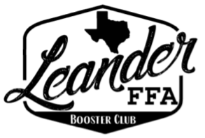
LHS FFA Booster Club General Meeting
April 14, 2026

Committee Reports

President:
- Banquet is (May 11th) ticket sales is live on Zeffy; will turn off May 4th
  - Tickets: $10 students; $15 adults
  - Rosati’s Order
    - 80 people = $705.94
    - 100 people = $822.93
  - Silent Auction: donations still needed; 32 donations received
  - Auction basket assembly session April 30. Time to be announced.

Treasurer:
- Current Balance = $17,031.59
- Earnings this fiscal year = $11,397.94
- Income earned since previous meeting:
  - $775 from Mulch Sales
  - $55 from Banquet Sales
- Expenses incurred since previous meeting:
$3.00 iPostal Charges

Fundraising:
- Mulch Fundraiser: Order Deadline is Friday
  - Please take a stack of door hangers; Sold 160 bags so far
- Spirit Nights
  - Guaco Taco: 4/20
  - Brooklyn Heights: 5/20

New business:
- Booster Club training required by district will be April 22nd at 6pm

Chapter Report:

Sponsor Report:

Important Dates:
April 20th: Guaco Taco Spirit Night
May 11th: Awards Banquet
May 20th: Brooklyn Heights Spirit Night
May 29th: Graduation

Paid Members:

Allison Thompson
Colely Thompson
Amy Kale
Amy Wheeler
Doug Wheeler
Karen Saxer
Lyle Grimes
Elexis Grimes
Matt Dunnam
Nicole Hoelscher
Heather Westmoreland
Melissa Smith
Aaron King
Karen Vasquez
Jenn Sturdevant
Leslie Trevino & Spouse

