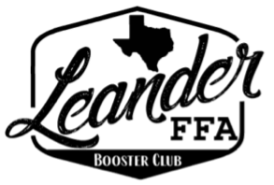
LHS FFA Booster Club General Meeting
January 27, 2026

Committee Reports

President:
No February Meeting
Scholarship Deadline: March 30th (?) Need a scholarship Chair
March Meeting will review by-laws and any proposed changes

Treasurer:
Current Balance = $21,570.25
Earnings this fiscal year = $10,525.09

Spend so far = $993.54 of $14,016.51 expense budget
WCLA: $1,000 will be invoice, TBP

Fundraising:
Promote FFA Trade Day: April 11th

Sponsor Report:

Important Dates:
GLFAA Swine & Ag Mech Show: January 27th
GLFAA Auction: January 30th at Cedar Park Recreation Center begins 2pm
Set-up 11am for Jr Superintendents

Paid Members:

Allison Thompson
Colely Thompson
Amy Kale
Amy Wheeler
Doug Wheeler
Karen Saxer
Lyle Grimes
Elexis Grimes
Matt Dunnam
Nicole Hoelscher
Heather Westmoreland
Melissa Smith
Aaron King
Karen Vasquez
Jenn Sturdevant
Leslie Trevino & Spouse

