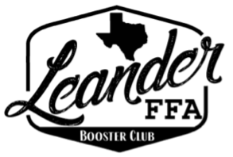
LHS FFA Booster Club General Meeting
January 13, 2026

Committee Reports

President:
FFA Trade Day: April 11th 9am-12pm; Parking lot behind stadium is reserved
Zeffy Registration & Flyer Created
Student Registration: $10
Vendor Registration: $100

Treasurer:
Current Balance = $21,169.14 (Does not include Kendra Scott check $401.11)
Earnings this fiscal year = $10,123.98

Spend so far = $993.54 of $16,016.51 expense budget
WCLA: $1,000 will be invoice, TBP

Fundraising:
Spirit Nights:
1/19/2026: Great American Cookie in Leander 20% from entire day of sales

Current Business:

New Business:

Chapter Report:

Sponsor Report:

Important Dates:
8th Grade Night: January 15th
GLFAA Set-up: January 19th @ 9am
GLFAA Show: January 22-24th
GLFAA Auction: January 30th at Cedar Park Recreation Center

Paid Members:

Allison Thompson
Colely Thompson
Amy Kale
Amy Wheeler
Doug Wheeler
Karen Saxer
Lyle Grimes
Elexis Grimes
Matt Dunnam
Nicole Hoelscher
Heather Westmoreland
Melissa Smith
Aaron King
Karen Vasquez
Jenn Sturdevant
Leslie Trevino & Spouse

